Database Schema :
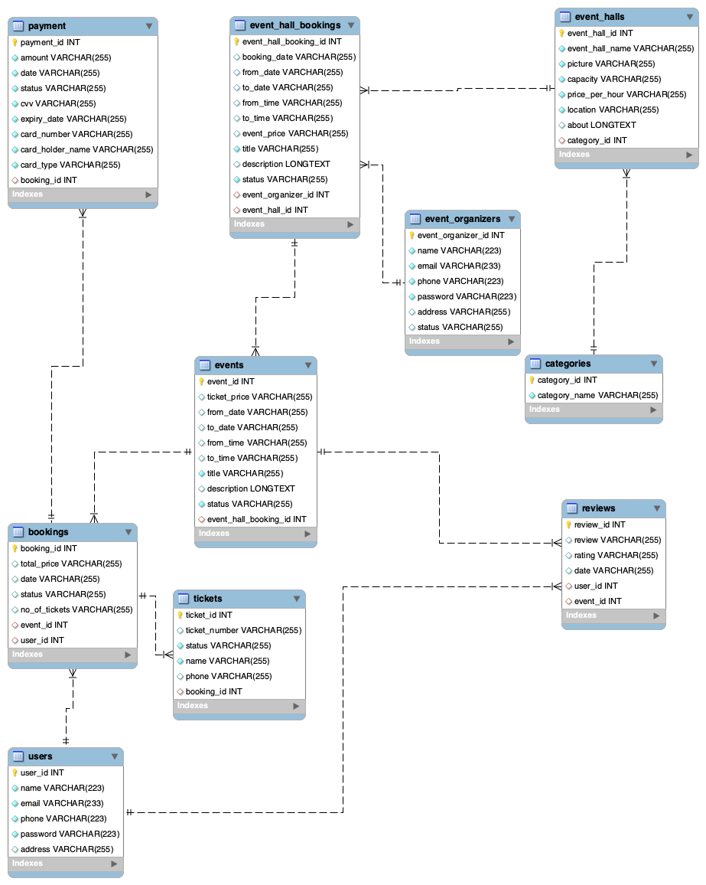
The Event Management System database is designed to efficiently handle event hall bookings, event scheduling, payments, and user interactions. It establishes structured relationships between Admin, Event Organizers, Users, and System Entities such as events, bookings, tickets, and reviews. Each table is linked through foreign keys to ensure referential integrity and smooth data flow across the system.
At the core of the database are three major user roles - Admin, Event Organizer, and User - who interact with the system’s core entities. The Admin manages event halls, categories, and organizer verification. Event Organizers create events and book halls, while Users browse events, make bookings, purchase tickets, and provide Reviews.

Firstly we create the database like this and here we have 10 tables :


1. Categories
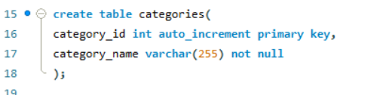
- Purpose: Stores the different event categories (e.g., Wedding, Conference, Party).
- Primary Key: category_id
- Relationship: Connected to event_halls table, categorizing halls under specific event types.

2. Event_halls
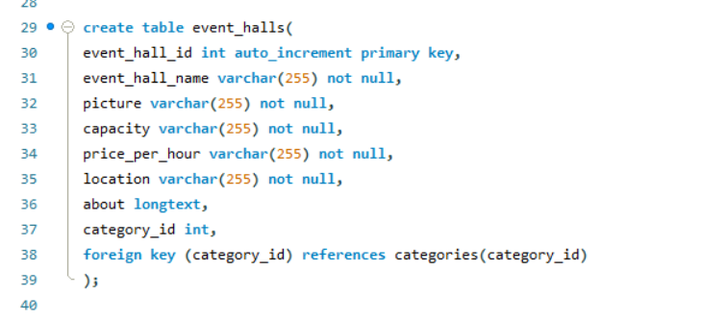

- Purpose: Contains details of each hall available for events.
- Attributes: Hall name, picture, capacity, location, description.
- Primary Key: event_hall_id
- Foreign Key: category_id (links each hall to its category).
- Relationship: Linked with event_hall_bookings for managing hall reservations.

3. Event_hall_bookings
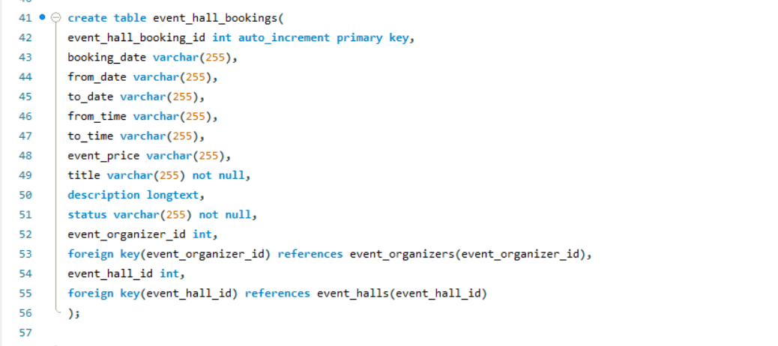
- Purpose: Records the hall booking details made by event organizers.
- Primary Key: event_hall_booking_id
- Foreign Keys:
  - event_hall_id : from event_halls
  - event_organizer_id : from event_organizers
- Attributes: Booking date, duration, description, and status.
- Relationship: Connected to events to associate specific events with booked halls.

4. Event_organizers
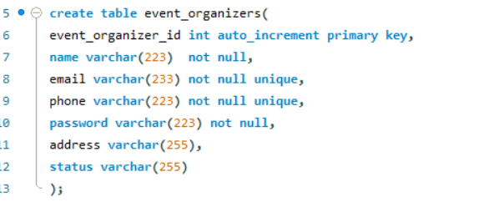
- Purpose: Manages registered organizers who create and host events.
- Primary Key: event_organizer_id
- Attributes: Name, email, phone, password, address, and verification status.
- Relationship:
  - Linked to event_hall_bookings for booking halls.
  - Linked to events for creating and managing event details.

5. Events
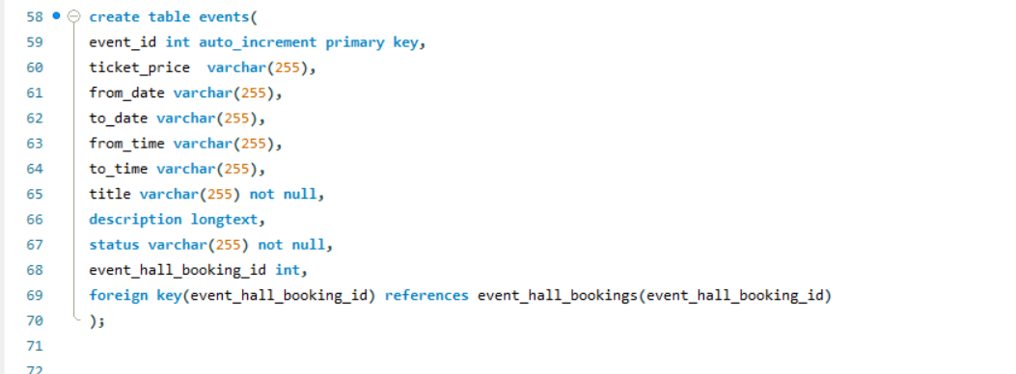
- Purpose: Contains all event-related details like name, date, time, price, and description.
- Primary Key: event_id
- Foreign Key:
  - event_hall_booking_id : connects to event_hall_bookings
- Relationship:
  - Linked to bookings and reviews for tracking participation and feedback.

6. Users
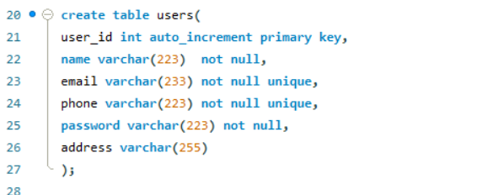
- Purpose: Represents registered users who can book tickets and attend events.
- Primary Key: user_id
- Attributes: Name, email, phone, password.
- Relationship:
  - Linked to bookings (user event reservations).
  - Linked to reviews (event feedback submission).

7. Bookings
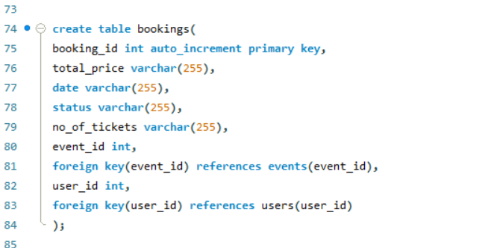
- Purpose: Manages event bookings made by users.
- Primary Key: booking_id
- Foreign Keys:
  - user_id : from users
  - event_id : from events
- Attributes: Ticket price, total tickets, booking status.
- Relationship:
  - Connected to tickets for generating physical or digital entry passes.
  - Linked to payment for payment tracking.

8. Tickets
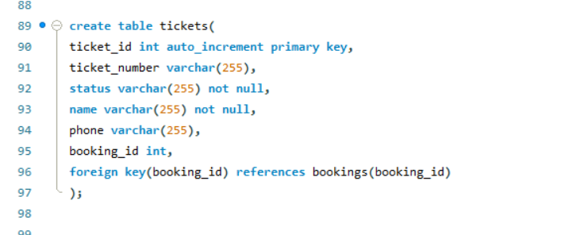
- Purpose: Stores ticket details for each user’s booking.
- Primary Key: ticket_id
- Foreign Key: booking_id : from bookings
- Attributes: Ticket number, status, user contact info.
- Relationship: Each ticket belongs to a booking made by a specific user.

9. Payment
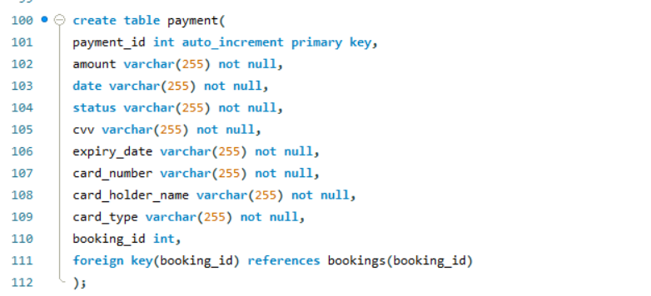
- Purpose: Handles payment details for event bookings.
- Primary Key: payment_id
- Foreign Key: booking_id : from bookings
- Attributes: Amount, payment date, card details, and payment status.
- Relationship: Each payment record is linked to a specific booking for tracking financial transactions.

10. Reviews
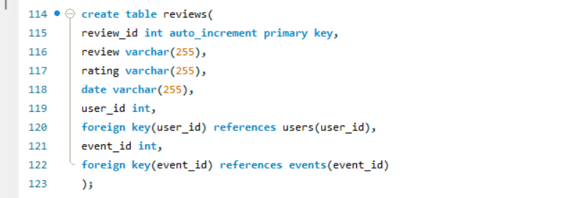
- Purpose: Stores user feedback and ratings for attended events.
- Primary Key: review_id
- Foreign Keys:
  - event_id : from events
  - user_id : from users
- Attributes: Review text, rating, and date.
- Relationship: Helps improve event quality and provides insights for organizers.

Sample snippets :

1. Categories
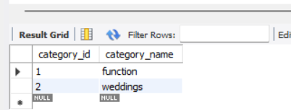

2. Event_halls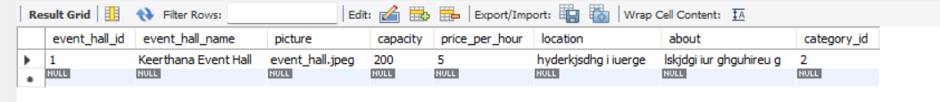

3. Event_hall_bookings
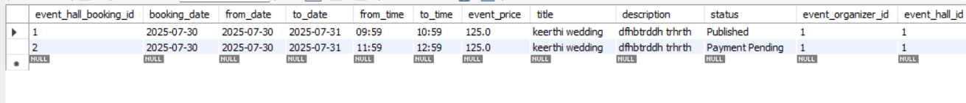

4. Event_organizers
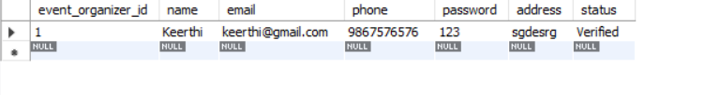

5. Events
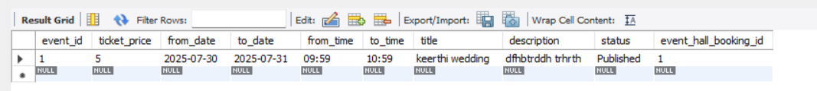

6. Users
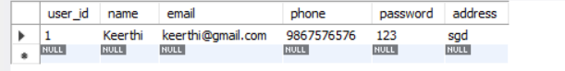

7. Bookings
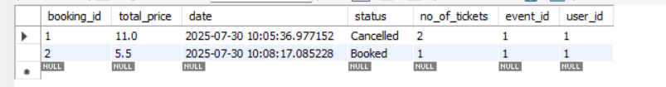

8. Tickets
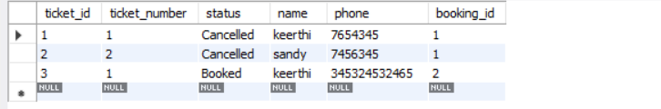

9. Payment

10. Reviews



